**W E T H A N K O U R S P O N S O R S**

**P L A T I N U M**

**B o a r d o f** **D i r e c t o r s**





**G O L D**

**I n H o n o r o f**   
**A n d r e w W . E d w a r d s**

**S I L V E R**

**N e l s o n T . L e w i s C o n s t r u c t i o n**

**E x e c u t i v e T e a m**

**B R O N Z E**



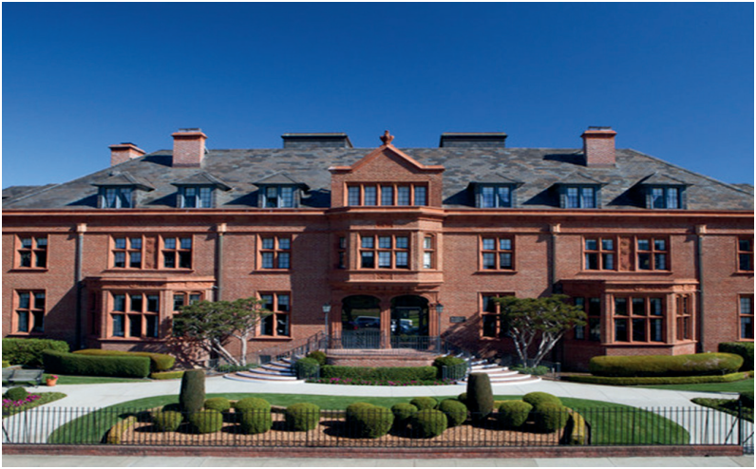

**THE**

**T o m K i n g**

**T h e o A r m o u r**

**K e v i n G e r b e r**

**JULIA MORGAN**

**R O A R I N G T W E N T I E S**

**C E N T E N A R I A N S**

**M a r t h a N e l l B e a t t y**

**P a t t i G a l l a g h e r**

**A l v i n L o c h a n**

**BUILDING** **CELEBRATING**

**C E L E B R A T I N G O U R C E N T E N A R I A N S**

**CARM ARBURUA** **BETTY DOWELL**

**ENID LEFF** **MARGARET JOHNSON**

**10100 0YEARS**

**MARCH 27, 2025**

3400 LAGUNA STREET, SAN FRANCISCO, CA 94123

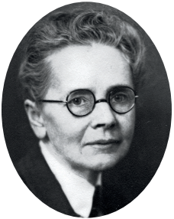**PROGRAM**

**2 : 0 0 P M**





**Morgan (January 20, 1872 – February 2, 1957)** **n American architect and engineer. She designed**

**W I N E & H O R S D ’ O E U V R E S R E C E P**   
**G U I D E D T O U R S 2 N D F L O O R G A L L E**

**2 : 4 5 P M**

**W E L C O M E & I N T R O D U C T I O N S**   
**M A R Y L I N D E , C E O**

**L A N D M A R K D E S I G N A T I O N**

**than 700 buildings in California during a long** **rolific career. She is best known for her work on**

**st Castle in San Simeon, California.**

**1922 to 1925, Julia Morgan was enlisted to design** **arding home to house elderly women in San** **cisco. Today the building is home to Heritage on**

**Marina, San Francisco’s premier Life Plan**

**C A R O L Y N K I E R N A T , P A G E & T U R N**

**H I S T O R Y & B U I L D I N G S Y M B O L S** **T H E O A R M O U R , R E S I D E N T**

**C A R O L Y N K I E R N A T , P A G E & T U R N**

**P R E S E R V I N G O U R L E G A C Y**   
**R A N D Y G R I D L E Y , B O A R D C H A I R**

**P R E S E N T A T I O N O F P R O C L A M A T I O** **A N D O T H E R S**

**C L O S I N G R E M A R K S**

**D R . L A U R A W A G N E R , B O A R D M E M**

**B U L L**

**B U L L**

**N S**

**B E R**

**munity. The beautiful Julia Morgan building is** **d and operated by the San Francisco Ladies’** **ction and Relief Society, one of California’s first**

**nthropic organizations, established in 1853.**

**3 : 3 0 P M**

**G U I D E D T O U R S 2 N D F L O O R G A L L E R** **G U I D E D T O U R S O F B U I L D I N G S Y M**   
**4 : 0 0 P M**

**A D J O U R N**